Social Media Marketing Campaign Report for Under Armour Australia (Part B)

Student’s Name
Department, University Name
Course Code: Course Name
Instructor’s Name
Date of Submission

Social Media Marketing Campaign Report for Under Armour Australia (Part B)
Campaign Background
Company Background
Under Armour (UA) is a US-based company that deals in sports ware manufacture and distribution across the world. The company also markets its brand products that cover men majorly at 69% (James & Whitney, 2018). Among the commodities distributed are apparels, masks, headgear, bags, and gloves (James & Whitney, 2018). As an emerging company and considering the developments in the sports industry, the company’s focus is to tap the attention of more sports personalities in America, Europe, Africa, Asia, Australia, and the Middle East. This is an initiative is management believes is attainable through strategic market invasion and leveraging on technology. The firm aims to have a competitive advantage ahead of other firms such as Adidas and Nike, who are giants with a long history in the industry (Liew, 2020). Consequently, Sternthal & Malaviya (2018) state that the management has realized that an effective campaign that would help the company attain its desires must be through a social media platform that will access most of its targeted clients who are the youths and teens.
The company’s previous social media campaigns include user-generated content to tell its high-performance story effectively. For instance, the company has used shopper reviews, videos, images, shoppers donning its products, and customer ratings, including feedback from its “wear-testers” like Stephen Curry and Dwayne Johnson (Armour, 2021). Additionally, the firm has also used an emotional mobile video campaign where participants on various social media platforms shared the content posted (Armour, 2021). The campaign aimed to create an emotional bond with customers to forge customer loyalty. It emphasized the need for the participating runners to prove their love for running. The company understands the impacts of social media marketing in reaching out to its wide audience. Thus, it employs famous people, especially celebrities and renowned athletics, to advertise its products (Armour, 2021). The main objective is to win the followers of such influencers to become part of the company’s customers
Situation Analysis
The company that began its operation as a tiny shop has finally expanded to have over 300 stores across the world and15,000 employees. Furthermore, James & Whitney (2018), state that the firm has resolved to support sports in Black nations where it is seen supporting women and children. This is a step towards diversifying its customers to all gender. Moreover, amidst little employees’ complaints, the firm’s expansion rate has been occasioned by their clear development plans that intend to hit a AUD900 million mark revenue by the end of 2021 (Armour, 2021). The company enjoys internal strengths such as good community relations, faster market expansion, and high revenue that is constantly growing due to the market expansion. Some of its opportunities are online marketing that taps many youths, cooperation with the NBA, which has opened more opportunities to the firm, and conquest of the Australian market that has been idle for a long (Armour, 2021).
Nonetheless, the company is not free from weaknesses and threats. Its recent market entry and production of some defective products add more weight to the high competition in the industry to derail its progress (Armour, 2021). The most established entities such as Adidas, Puma, and Nike are its greatest competitors in the market, thus limiting its hopes of faster growth. Its recent market entry raises trust and loyalty concerns and this makes it not perform effectively like other notable giants. The major weaknesses of Under Armour are that it is a new company with a limited presence and stores in few markets. This situation complicates its market approaches since its competitors have an advantage over it. The company’s brand athletic cups were recalled for the possibility of causing injury to users. Such defects add setbacks in the firm’s bid to gain fame and expand its markets.
Campaign Objectives
The company has realized its potential in the sporting industry. With the rise in technological application in the industry, the firm would not want to forgo any opportunity that may make it attain its target of market expansion and reach a wider consumer base. The firm’s campaign aims to market its brand among sporting celebrities, sponsors, clubs, and companies across the world (Sternthal & Malaviya, 2018). As a result, UA has a campaign objective of increasing brand awareness and stickiness among youths. This is the mechanism it believes will give an avenue for immediate feedbacks and reactions while it necessitates open interactions. Consequently, the firm is seeking a campaign platform that will offer an environment of consistent engagements with its targeted audience. Winand et al. (2019) point that social media is becoming a key sports partner in various avenues. Therefore, the firm’s objective is to exercise the connection through a sustainable platform.
Target Audience Profile
The target audience for this marketing campaign are the youths and children. Specifically, this campaign will target the youths teenagers between the age of 14 to 18 year and children from age five to 13. The reason for slecting these two target audineces is that they form the bulk of the most active people in society in terms of intense sporting. Children from age 5 to 13 are more active aand as parents and teachers discover the talents of their kids, they feel more obligated to provide the necessary and appropriate sporting gear for them. Ad as such, even though the campaign will target the children, the fact that children don’t earn their own money automatically means that the social media marketing campaign will be targeting their parents and guardians in disguise. At age 5 to 13, parents still take care of their kids fully and therefore, the provide almost everything required by their kids.
Secondly, at the lower ages of 5 to 13, children are still more playful as they admire their hirroes in the adult sporting activities. Therefore, the do not understand issues of lack of money and such like problems. They are likely to push their parents to the limit to get them appropriate shoes and attire for their various sports that they admire. This way, Under Armour Australia will sell more as the parents will be under immense pressure from their children to take advantage of the deals advertised in the two social media posts that will be discussed below.
Currently, the youths form the bulk of sports personalities. They lead in buying sports gear and equipment either directly or through clubs, parents, or other institutions. Moreover, under the current situations, children influence household spending and decision-making when it comes to buying sports apparel. Parents are increasingly investing in their children in the name of love; hence, the children’s choices matter a lot to them. A higher affinity for a specific brand benefits the chosen brand in terms of sales and brand loyalty (Armour, 2021). Over 40 % of youths between 5 and 18 years play some form of sport every year (Appendix 2).
Teenagers, especially those fro the age of 14 to 18 are active social media users and as such, they form a good target for a social media campaign for this company. The include senior school studensta dn early college students who are trying to shape their sporting careers. They are more serious with sports and some of them are looking forward to joining established sports clubs. Under Armour can target this bunch of youths because they are active purcahsrs of sports geer. And since many are not yet working, they alo have full support of their parents while those above 18 can work to obtain their own money t buy sporting gears. Youth sports in Australia are a tremendous business with an impressive growth of 5% annually (Armour, 2021). Under Armour needs to seize the emerging power of children in the apparel sector to harvest the segment’s lucrative returns for their gain and development. The firm is aware of the sports industry’s rising importance and youth involvement in the activity. They plan to capture this population through a channel of their choices that would see the two parties enjoy the outcome of their collaboration. This move will enable the firm to incorporate a convincing future and growing reliable customer base that it can count for revenue generation.
Social Media Strategy
Considering the age brackets of its audience, the firm has to deploy a platform that meets their taste and expectation. The company needs to find and develop a framework that ties their target around their products and such a mechanism should build a lasting relationship as the youths grow to become notable sports personalities. Thus, the company needs to use the social communities in its bid to reach the youths due to the zone’s capacity. Currently, no international company operates out of the social media framework and every sports institution has access to the social communities. Similarly, the audience the company is seeking is the majority of users of the social community pages today. According to Naraine (2019), sports marketing is controlled by the following factor, which describes the users. The targeted audience in this marketing strategy is today the largest users of the social community network.
The social community zone has several channels of relaying information to the consumers. UA company should dwell on the vehicles that it trusts will reach the highest number of the targeted audience. Moreover, the form of information or mechanism of the marketing will determine the vehicle to be used. Having used other channels such as magazines which are not common among the youths today, the firm has to change tact in the next approach to remain relevant and gain in its pursuit. Facebook and Twitter are two formidable vehicles for this marketing campaign strategy. Just as Naraine (2019) explains the user factor, Sternthal & Malaviya (2018), also state that the UA company plans to use a vehicle that can conveniently reach its audience for a long period and at manageable costs (Appendix 3). Additionally, Facebook and Twitter conduct their updates conveniently and periodically, making it possible to access the information as much as a person may want. Access to the vehicles is common due to little restrictions and with the current digital learning, the firm is sure to meet its target.
Communication through these two avenues is easier as it can be made through simple photos, videos, and texts. The company can manage its pages and conduct uploads or updates easily from the offices. Having a variety of graphic representation of the products posted on the Facebook or Twitter accounts reach several users, particularly the targeted ones who are major users of the zones. The content that is admirable to this target group is pictures (Appendix 4). The age group targeted is attracted by beautiful graphic works and this should be an opportunity for the company to take pictures of their gears, apparel, masks, and shoes and post them on their pages. The pictures taken should be of individuals donning the products (Appendix 4). Winand et al., (2019) report that the smartness with which the pictures feature will catch the attention of many page followers who may seek more information (Appendix 5). Additionally, posting the communications on the Facebook walls of targeted sports entities boosts the marketing bids. Therefore, the firm needs to be more creative and innovative as they post their advertisements to back the bid.
Scheduling
A social media campaign should be progressive and covering. The company will have to employ frameworks that ensure its adverts are well spread in a day and are viewed by the majority of the sought audience. The firm may opt for limitless photos in a frequency of 4 posts a day. The number of pictures can vary but not too much to bore the targeted group. Posting done in the morning, afternoon, evening, and at night means that the coverage cares for the interest of every target irrespective of their engagements. Additionally, this can be done daily because the social vehicles in the zones are open for access at any time (Appendix 6). The youths and teens may be engaged but cannot miss chances of visiting the vehicles at least once a day or in a week. Since the posts remain unless withdrawn by the firm, they still can view them later. With continuous postings, the avenue becomes schedule reliable.
The Budget
Several marketing costs will be required for this strategy to succeed. Some of the most important ones are content creation which includes talent from actors and models, production of props and location rentals, graphic design, copywriting, editing, video production, and photography. Other important costs are for content creation paid to the creators, training on how to use the vehicles and the terms governing usage, and the software tools required for the advertisement, and the user rights paid to the companies owning the vehicles used. Costs will vary significantly depending on how the specifications of the company’s social media content. Moreover, even though there are free mechanisms of advertisement through the channels, the firm can pay for ads to expand the base of a campaign to reach wider customers’ dimensions. As James & Whitney (2018) put it, the company’s resolve to conquer the sports industry would not allow t rely on free modes of adverts through the vehicles, but it will spend on additional mechanisms to realize that.
The costs of each input vary but the company has proper strategies for harmonizing the costs through prioritization. According to Hootsuite (2021), the company will spend AUD 65 per hour in copywriting, AUD 50 per hour in copy editing, AUD 2 per day for Facebook posts and Twitter handle to use. Additionally, the company will pay the two influencers for each vehicle AUD200 for a group of 20,000 followers per day, while the training will be done after every four months for AUD4000 for a single day. The social media campaign team will consist of 5 employees paid a cumulative amount of AUD180,000 in a year (Appendix 7). As a result, the total estimate for running the campaign in a month is AUD21,130. Notably, all these costs are estimates from the Hootsuite (2021) 2020 market rates and budgets.
Metrics and Measurements
There are various modalities of assessing the performance of this campaign. The four main ones are customers, leads, reach, and engagements. It is important to examine the progress and the efficiency of mechanisms, vehicles, budget, and all other factors used in the process. Liew (2020) asserts that to realize maximum gain from the social media approach as a marketing campaign tool, an entity must conduct continuous metric measures to avoid last minutes revelation of losses or missed concepts. The key issues the project management team should focus on are the questions of whether the adverts are leading them to the right audience, whether they are reaching the correct group, how they qualitatively engage the groups they interact with and whether those that they engage can be retained and become customers (Romana Sukhraj, 2021). If the answer to any of these questions, the firm should quickly address the situation so that it satisfies the key performance indicators.
Moreover, the responses and reactions of the targeted groups become the greatest key indicators in the campaign. These are examined through consistent checks on features such as clicks, likes, comments, shares and brand mention among the targeted audience (Romana Sukhraj, 2021). That is the criterion that leads to a successful social media campaign. Other notable signs are followers, impressions, and profile visitations (Romana Sukhraj, 2021). Other than the key indicators, other particulars can be used to measure the performances of the strategies employed in the campaign. Amongst them are employees’ satisfaction and financial performances indices. The employees’ attitude towards the strategies should be assessed to help the firm establish effective relationships. Furthermore, the amount earned needs to be higher than that spent to create sustainability in the processes.
The firm can conduct its internal survey to examine the responses employees give concerning the market campaign. It will then decide on what to do depending on the number of those supporting the practice against those opposing it. Additionally, conducting financial analysis is a basis for planning and assessing the profitability and sustainability of the campaign. By determining the amount spent in the budget and comparing the amount gained after the procedure, the firm can find a better way of running the campaign if the vehicles chosen do not favor it. Moreover, the company is at liberty to compare its progress with other firms to help it make proper steps.
Other Considerations
A social media campaign requires several considerations. Apart from the audience, the media, and the costs, UA company will consider legislative requirements as a paramount determinant for the efficacy of their project. Legislation can be felt from both internal and external spheres of the organization. The usage of social platforms is regulated in some countries while others do not control it. It is ideal for the firm to assess the spread of their audience to necessitate careful planning. Furthermore, the contents posted in media are currently under strict cyber security watch and the firm has to be concerned that what is shared does not go against such provision (Bentley et al., 2021). On the other side, some targeted audiences misuse the platforms and they may cause threats to the firm (Bentley et al., 2021). The firm needs to establish regulations that govern their cooperation to curtail negative instances that may infringe either of the parties’ rights.
The next consideration the firm should have is the changes in social media customers’ tastes and preferences in response to seasons, especially in sports. Most sporting activities, especially football with the widest fanbase, have seasonal calendars (James & Whitney, 2018). This means that the targeted audience in some cases, loses interest in social media following due to the fluctuations. The company in its strategies should have that in mind and make seasonal plans. These plans should aim to reach the groups when the seasons are high, specifically during game times where many youths follow scores through Facebook and Twitter. This becomes the best opportunity for popping ads as the game progresses.

References
Armour, C. (2021). The regulator: Change in the weather. Company Director, 37(1), 34-35.
Bentley, K., Chu, C., Nistor, C., Pehlivan, E., & Yalcin, T. (2021). Social media engagement for global influencers. Journal of Global Marketing, 1-15.
Hootsuite. (2021). How to Create a Social Media Budget for Every Size of Business. Retrieved from https://blog.hootsuite.com/the-7-components-of-every-social-media-budget/
James, C. R., & Whitney, K. (2018). Under Armour: repositioning for the global stage. The CASE Journal.
Liew, J. K. S., Budavari, T., Kang, Z., Li, F., Wang, X., Ma, S., & Fremin, B. (2020). Pairs trading strategy with geolocation data-The battle between Under Armour and Nike. The Journal of Financial Data Science, 2(1), 126-143.
Naraine, M. L. (2019). Follower segments within and across the social media networks of major professional sport organizations. Sport Marketing Quarterly, 28(4), 222-233.
Romana Sukhraj. (2021). Social marketing. Social media KIPs. Retrieved from https://www.impactplus.com/blog/social-media-kpis.
Sternthal, B., & Malaviya, P. (2018). Under Armour: Creating and Growing a New Consumer Brand. Kellogg School of Management Cases.
Winand, M., Belot, M., Merten, S., & Kolyperas, D. (2019). International sports federations’ social media communication: A content analysis of FIFA’s Twitter account. International Journal of Sport Communication, 12(2), 209-233.
Appendices
Fig. 1 SWOT Analysis Table
Strengths | Weaknesses | Opportunities | Threats
- Expansion capacity is high due to its recent market entry  - Favoured through good community relations  - Revenue generation is high due to good relations  - Revenue generation is in constant growth | - Recent market entry implies fewer markets and customers  - Defective products which lead to poor customer relations mainly in athletic kits | - Online marketing is a chance for success  - Ability to cover the unexploited Australian market  - Partnership with NBA is an avenue for greater avenues such as marketing | - Competition from brands such as Adidas and Nike  - Injury-prone products may reduce the brand escalation  - Limited market awareness due to late entry

Fig. 2 Audience Profile
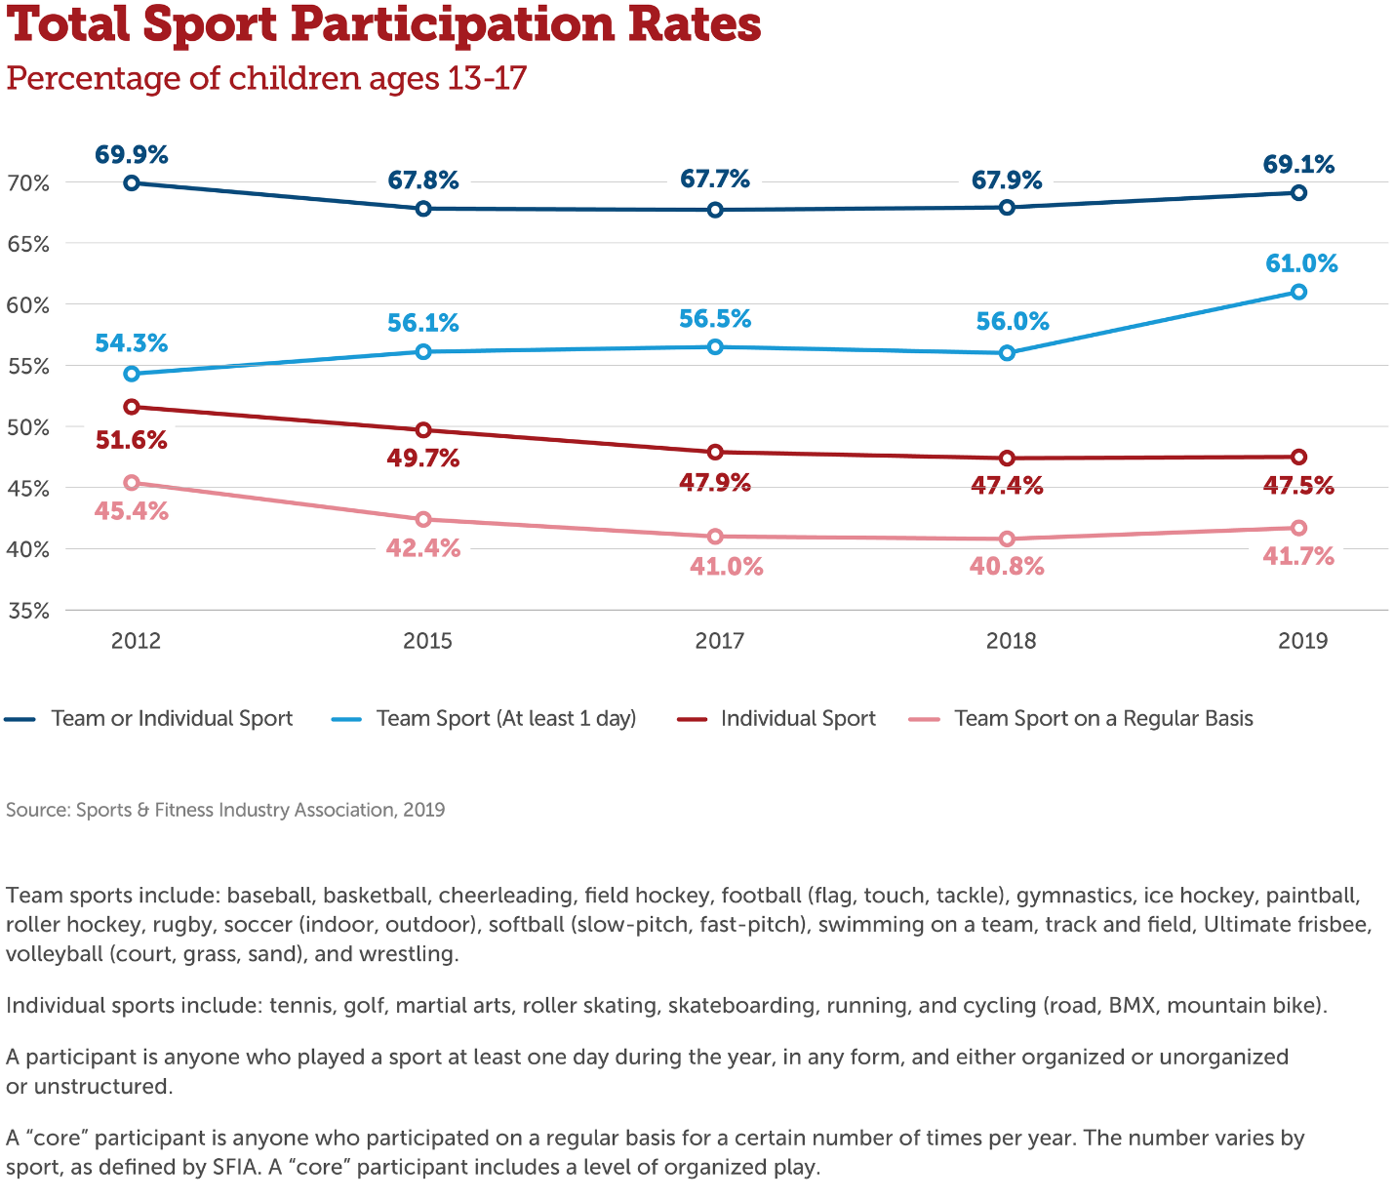
Fig. 3 Content Strategy Document
Social Media Zones | Social Communities
Channels | Facebook and Twitter
Contents | Photography
Goals | To reach the highest possible number of targets
Decisions | Innovation and creativity
Governance | regulations by the social media management team
Workflow | Creating a team of capable personalities
Offsite content | Ensuring relationship between the players

Fig. 4 Facebook Campaign Post
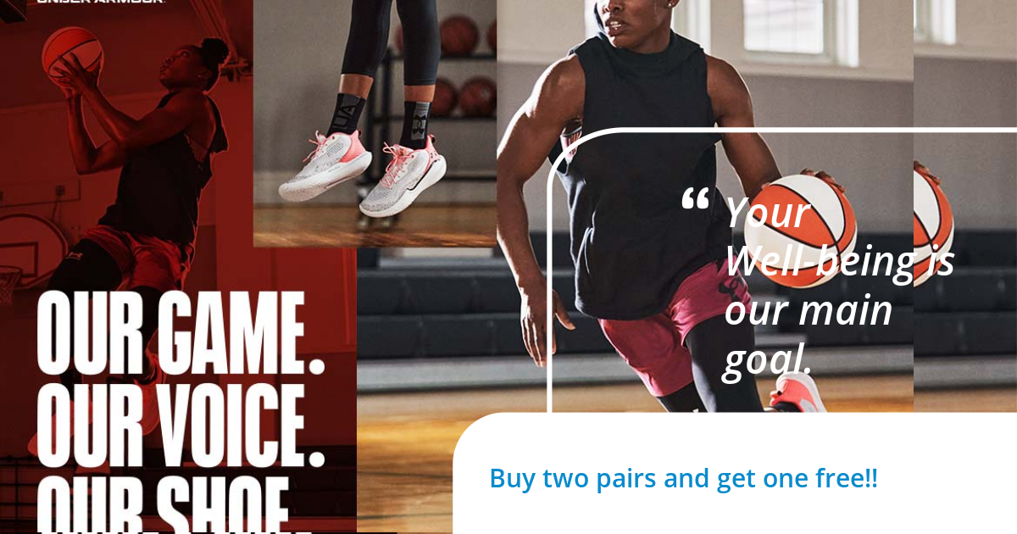

Fig. 5 Twitter Campaign Post
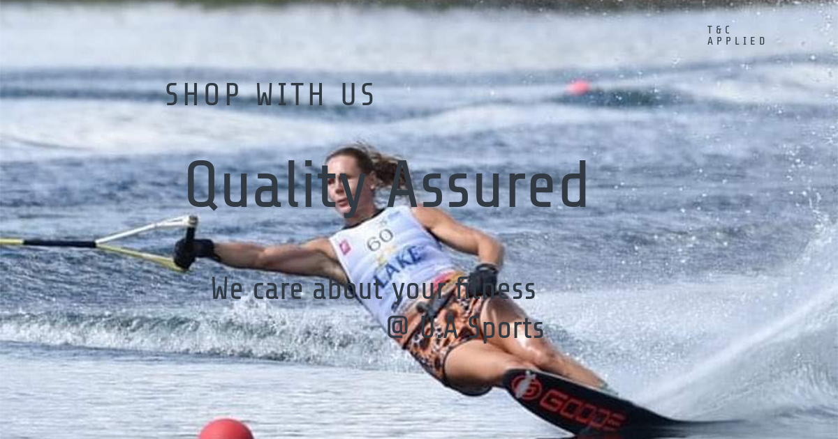
Fig. 6 Social Media Campaign Calendar
Week | Week 1 | Week 2 | Week 3 | Week 4
Activity | - Making Social Media Postings | - Checking the reactions  - Quantifying reactions and grouping them | - Analyzing the audience responses and reactions  - Engaging the audience | - Continuation of audience engagement  - Evaluating the activities of the month  - Assessing the outcome of the month’s programs

Fig. 7 A 30-Day Campaign Budget
Activity | Cost in AUD
- Facebook and Twitter chargers per day 4 by 30  - 2 Influencers 200 each per week  - Training  - 5 staffs Wages  - Copywriting 4 hours per month  - Copy editing 3 hours a month  Total spent | 120  1600  4000  15,000  260  150  21,130

